MainFrame Simulation Using Hercules Emulator

What is Hercules Emulator?
- What Hercules actually is:
Hercules is an open-source emulator that lets you run IBM mainframe hardware architectures (System/370, ESA/390, z/Architecture) on standard computers like Windows, Linux, or macOS. It emulates the CPU instructions and peripheral devices required to run mainframe OSes.
- Important nuance:
Hercules does not include the operating systems — you must supply them yourself. Operating systems such as z/OS or z/VM require IBM licenses and cannot legally be used without permission. Hercules can legally run some older public-domain mainframe OSes (e.g., MVS 3.8j).
- Technical implication:
This means Hercules provides hardware simulation, but no built-in software stack. To use it as a research environment you still need an OS and tools that support Zowe. Given that newer OSes like z/OS are proprietary, obtaining and configuring them is not trivial.

What it Simulates?
- z/Architecture CPU
- DASD storage
- 3270 terminal interface
- Basic mainframe I/O devices

Technical Feasibility :
- Requires manual configuration
- Requires licensed z/OS images
- Setup complexity is high
- Can run z/OS if legally obtained
Is Hercules Technically Feasible ?
Yes — for learning and experimentation
Hercules can emulate mainframe hardware and let you boot up older OS versions (e.g., MVS 3.8j) or open-source Linux variants compiled for IBM Z.
But not ideal for enterprise Zowe research
Zowe requires a functional z/OS environment with services such as z/OSMF and API mediation layers — not just hardware emulation. Hercules by default does not provide these services without installing and configuring full z/OS images first.

Legal and Practical Limitations:
- Licensing restrictions
- Complex setup
- Not cloud-based
- Zowe compatibility not guaranteed
- Because of licensing restrictions, Hercules users often work with:
- Older mainframe OS images (e.g., MVS 3.8j) that are out of copyright or available for educational use.
- Linux on IBM Z, which is not proprietary and can run under Hercules.
However, modern versions of z/OS — which include services such as z/OS Management Facility (z/OSMF) and REST APIs used by Zowe — cannot be legally run without IBM licensing. This limits how fully realistic a Hercules environment can get for Zowe research.

Steps to setup Hercules Emulator:
- Download MVS TK5 from link https://www.prince-webdesign.nl/tk5
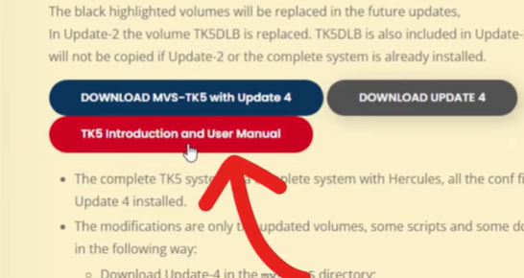
- Download Wc3270 from link https://x3270.miraheze.org/wiki/Downloads
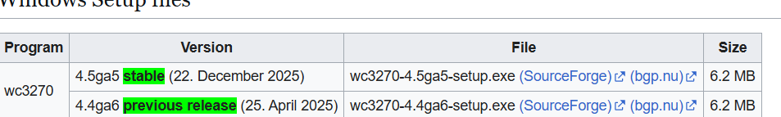

- Extract MVS TK5 application from the downloaded zip file
- Run mvs-tk5/unattended/set console mode(windows batch file)
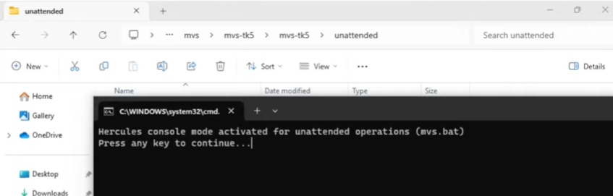
- Double click on mvs-tk5/mvs.bat file to run emulator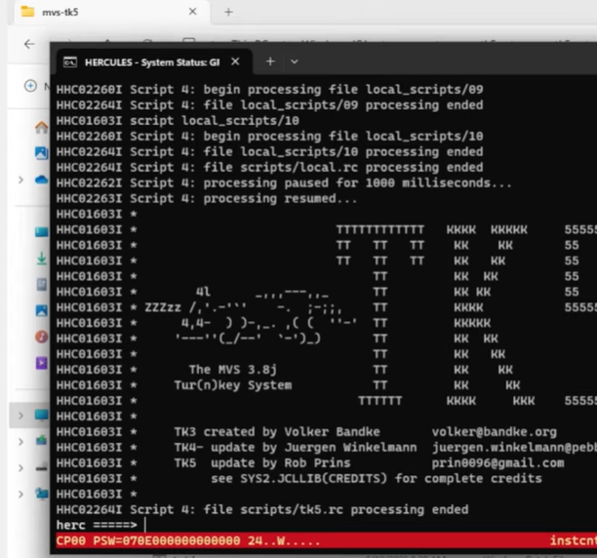

- Setup wc3270 from the installed file
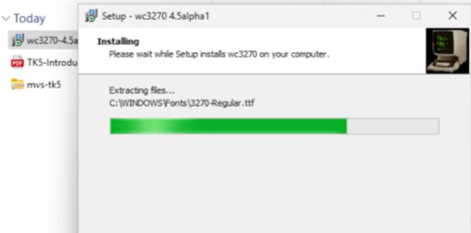

- Launch Wc3270
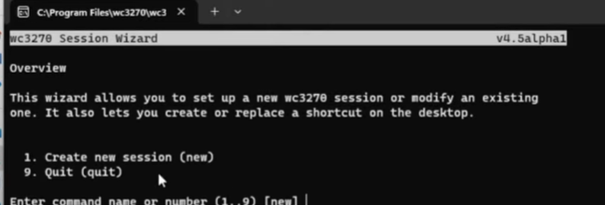
- Create new session – enter session name – enter host name or ip address as 127.0.0.1 – change TCP port from 23 to 3270
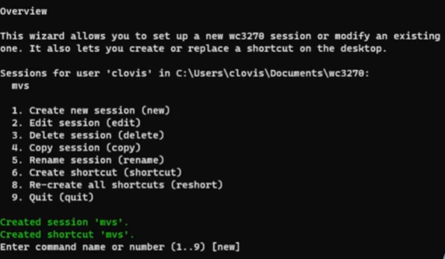
Quit the session
- Click on the desktop icon created for the session
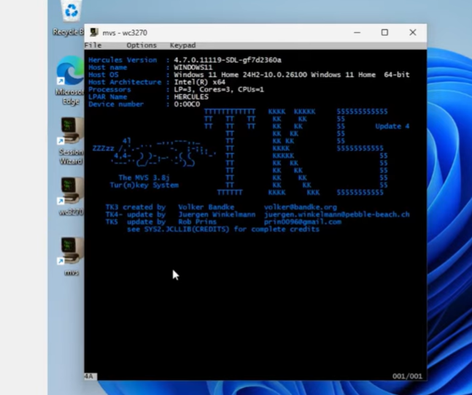
- We need to keep both mvs session and mvs-tk5 terminal open
- To send job files in the emulator refer video https://www.youtube.com/watch?v=Q2lICoXmY2E

IBM Skills /Cloud Learning Platforms:
Overview:
Most IBM mainframe learning environments are available through browser-accessible platforms such as IBM SkillsBuild, IBM Z Xplore, and IBM Z Open Editor extensions for Visual Studio Code. These allow users to interact with mainframe resources without installing local emulators.
Z Open Editor, for example:
- Provides integrated tools for COBOL, PL/I, JCL and more.
- Integrates with Zowe Explorer to access resources such as datasets and jobs.
- Can launch a 3270 emulator through Remote Connection Emulator when a proper host connection exists.
These environments do not emulate the full hardware like Hercules does, but instead provide access to a real or virtual mainframe backend for development activities

What IBM Z Skills Platforms Provide:
Instead of emulation, IBM offers cloud-accessible learning environments such as:
IBM Z Xplore
- A free, global learning platform that helps learners get hands-on mainframe experience through challenges and exercises.
- It introduces basic mainframe concepts such as datasets, coding languages (JCL, USS, Python), enterprise security, and more.
- It does not provide full system-level access, but allows you to practice core mainframe skills in the browser.
This means learners can get a taste of real mainframe operations without installing anything locally, but still cannot deeply configure services required for Zowe.

Tools Related to Zowe Integration:
Because Zowe is not just an emulator but a modern API and tool framework, other tools come into play:
IBM Z Open Editor & Zowe Explorer
These are tools you use from your local machine to interact with mainframe systems:
- IBM Z Open Editor is a VS Code extension that lets you edit mainframe code (COBOL, JCL, etc.) from a familiar IDE.
- It integrates with Zowe Explorer, which lets you connect to a real mainframe backend to browse datasets, USS, and submit jobs.
But these tools require a real z/OS system to connect to — they are not emulators themselves.

How IBM Cloud differs from Hercules Emulator?
Hercules Emulator: Hercules is an open-source mainframe hardware emulator supporting z/Architecture, ESA/390, and System/370 CPU instruction sets along with device emulation such as DASD and 3270 terminals. It allows mainframe operating systems and applications to run on standard computing environments, but requires a separate OS image and proper licensing. It is technically feasible for basic experimentation, but complex to configure and not immediately suitable for robust Zowe integration environments.
IBM Skills / Learning Platforms: IBM provides browser-based mainframe learning environments and tools such as IBM Z Open Editor which integrate with Zowe Explorer and support editing and interacting with mainframe datasets, jobs, and resources. These platforms are easy to access and useful for learning, but do not expose full system configuration or server-side services like z/OSMF natively.

1. Why Hercules Cannot Be Used as a Zowe Simulation Layer
Although the Hercules emulator provides a functional simulation of legacy IBM mainframe hardware and supports traditional artifacts such as JCL execution, dataset manipulation, and 3270 terminal interaction, it operates at the operating system and hardware abstraction layer rather than at the modern integration layer represented by Zowe.
Zowe functions as a REST-based façade over traditional z/OS components. In a real enterprise setup, Zowe translates REST or CLI requests into secure execution of:
- JCL batch jobs
- Dataset reads and writes
- Db2 queries
- System commands
The architectural layer of interest in this research is not the underlying mainframe execution environment, but the API-based integration layer that enables modern systems and AI agents to interact with legacy systems.
Hercules simulates:
- Terminal-driven command execution
- Direct JCL submission
- Text-based spool output
However, it does not provide:
- z/OS Management Facility (z/OSMF)
- Zowe API Mediation Layer
- REST-based service endpoints
- Token-based authentication or API routing
- JSON-native structured responses
Because this research focuses on how an AI agent interprets natural-language intent and selects appropriate Zowe-style commands (expressed as REST APIs), simulating terminal-level mainframe commands would represent a lower-level abstraction that does not align with the research objective.
Using Hercules would shift the focus from:
Agent → Zowe REST → IBM artifact
to:
Agent → Terminal/JCL → MVS
This would introduce unnecessary complexity while failing to model the modern API interaction patterns that Zowe is designed to enable.
Therefore, Hercules is unsuitable as the primary simulation mechanism for Zowe-based integration research.

2. Why IBM Cloud Environments Are Not Suitable for This Research
IBM Cloud environments and trial mainframe systems provide access to real or virtualized z/OS infrastructure. While these environments are technically accurate, they are not appropriate for this research context for the following reasons:
2.1 Access Constraints
The research team does not have sustained enterprise-level access to a production IBM mainframe environment. Trial or sandbox systems typically:
- Provide limited runtime windows
- Restrict administrative configuration
- Prevent installation of custom Zowe services
- Restrict deep system-level experimentation
This limits the ability to build and test a fully agent-driven orchestration layer.

2.2 Overemphasis on Infrastructure Instead of Research Focus
The primary research objective is:
To study how an AI agent can interpret plain-English requests and determine which Zowe commands must be executed.
Using IBM Cloud would shift significant effort toward:
- Environment setup
- Security configuration
- Credential management
- Network access management
- Infrastructure debugging
This detracts from the core research problem of agent reasoning and orchestration logic.

2.3 Reduced Experimental Control
A cloud-hosted mainframe environment introduces operational constraints:
- Rate limits
- Job execution limits
- Dataset restrictions
- Shared resource contention
For research that requires iterative simulation, reproducibility, and controlled experimentation, a self-contained simulated environment offers superior flexibility and traceability.

2.4 Research Scope: Integration Layer Simulation, Not Infrastructure Emulation
This research aims to simulate the Zowe interaction layer, not the underlying mainframe operating system. The architectural assumption being modeled is:
Agent / API Layer → Zowe-like REST Layer → IBM Artifacts
By simulating the Zowe REST interface and expected IBM outputs using structured mock services (e.g., REST endpoints, SQLite-backed datasets, and JSON spool outputs), the system remains:
- Architecturally aligned with real Zowe usage
- Fully reproducible
- Explainable and traceable
- Independent of external infrastructure
This abstraction accurately reflects how modern enterprise systems interact with IBM mainframes without requiring access to the mainframe itself.

3. Adopted Approach: Simulated Zowe REST Layer
Instead of emulating z/OS or provisioning IBM Cloud infrastructure, the adopted strategy is to simulate:
- Zowe-style REST APIs
- Job submission lifecycle
- Dataset access endpoints
- Structured JSON outputs
- Agent reasoning logs and explainability artifacts
This ensures:
- Architectural correctness
- Alignment with enterprise integration patterns
- Agent-centric orchestration modeling
- Full experimental control
- Extensibility toward real Zowe integration in future phases
The simulation layer reproduces the external behavior of Zowe without replicating its internal implementation, which is sufficient for evaluating agent decision-making, orchestration logic, and canonical data merging strategies.

Conclusion:
Based on the analysis, Hercules Emulator is technically feasible for learning and basic experimentation with legacy mainframe environments. It successfully simulates IBM mainframe hardware architectures such as System/370, ESA/390, and z/Architecture, allowing users to run older operating systems like MVS 3.8j or Linux on IBM Z. However, due to licensing restrictions, configuration complexity, and lack of built-in support for modern z/OS services such as z/OSMF and the Zowe API Mediation Layer, Hercules cannot provide a fully realistic environment for Zowe-based research.
In contrast, IBM Skills and cloud-based learning platforms provide easier access to mainframe resources and integration tools like IBM Z Open Editor and Zowe Explorer. However, these platforms are sandboxed and do not offer full system-level configuration required for deep Zowe experimentation.
Therefore, while both options are useful for learning and introductory exploration, neither fully satisfies the requirements for an enterprise-grade Zowe research environment. A properly licensed and configured z/OS system with z/OSMF and Zowe components installed would be necessary for comprehensive hands-on research.

